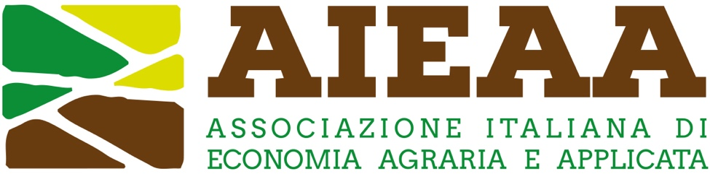

1st Young Researchers’ Day AIEAA
21 June 2023 University of Milan, Italy

Young Researchers’ Day 2023

Short bio (maximum 150 words)

…

Short abstract of an ongoing research project (maximum 500 words).
It must be in English and must be structured into: i) objective and research questions; (ii) methodology; (iii) findings or expected results.

…

What is the main challenge of your project?
Clearly indicate which is the main challenge that are facing in the project (literature review, data, methods…)
…

Imagine/Photo
Upload an imagine that could summarise their project

